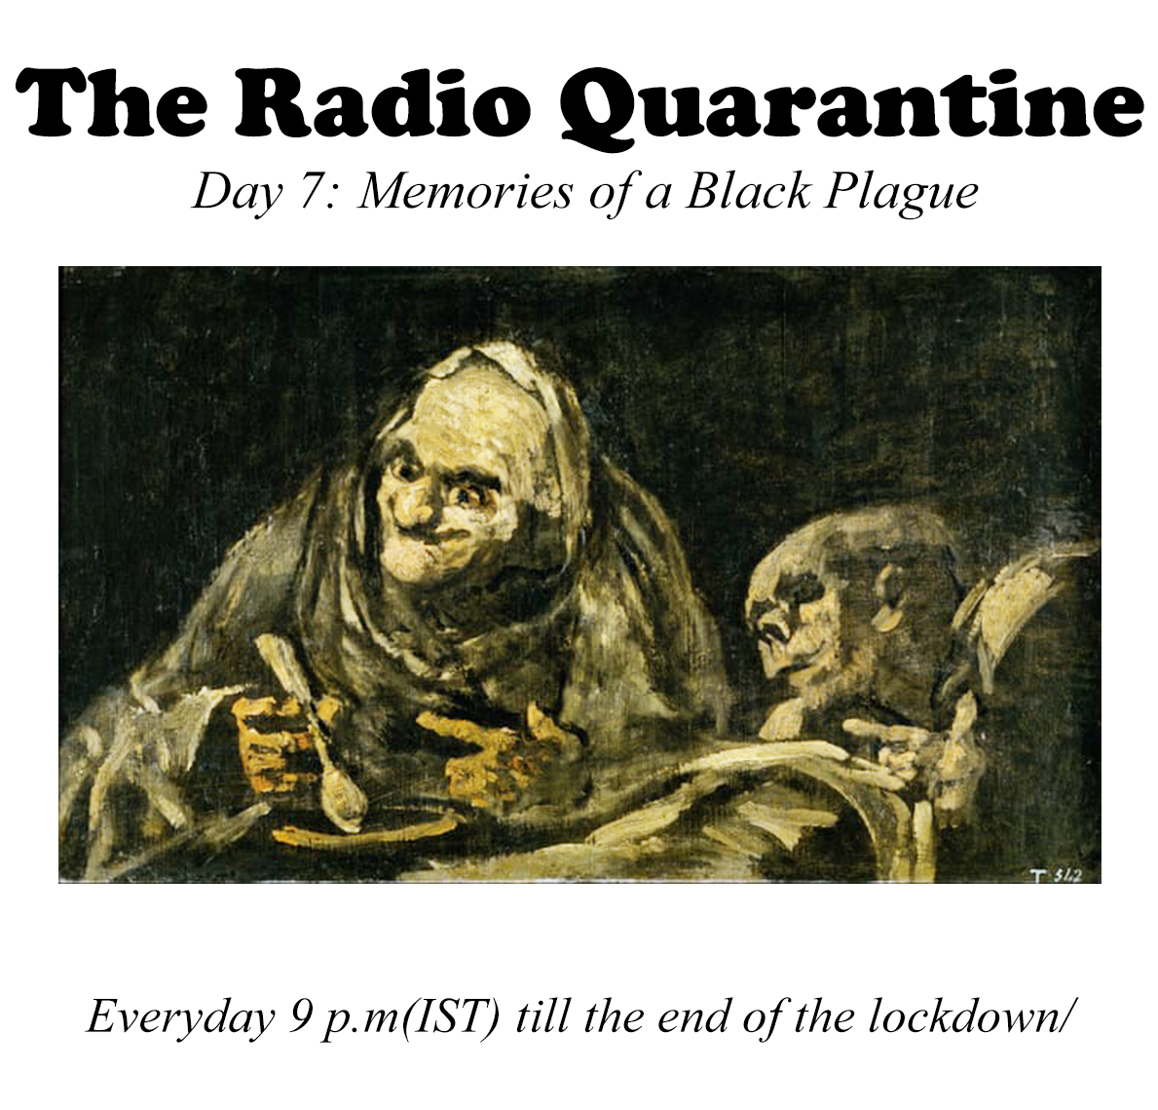

Day 07: Memories of a Black Plague

Tonight, we listen to Umashankar Mantravadi and his theory of labour and the plague in Europe. The plague played a significant role in European history. Will our current situation also be an epoch making event?

Music for tonight is excellent noise from around the world (including India)

We have more exciting interviews lined up for this week.

On Thursday, Dr.Satyajit Mayor, Cell biologist and the Director of the National Centre for Biological Sciences, Bangalore will talk about the virus, science and  society in India.

On Friday, the cosmologist Lord Martin Rees, the Royal astronomer of the United Kingdom, Professor of astrophysics at the University of Cambridge talks about the future of humanity.

Tonight's guest, Umashankar Mantravadi is a hacker par excellence. He makes some of the best ambisonic microphones in the world. Please visit <https://brahmamic.com/> for more information about his microphones.

@brahma.microphones/

Tune in, share the station with friends and Stay Safe.

Write back with questions, thoughts or opinions.

**Special Guest**

Umashankar Mantravadi / Sound Recordist, Microphone Enthusiast and Inventor talks about how many things – from good coffee beans to India’s emergency & censorship to how the Black Plague wiped out the labour class and how this lockdown is a beginning in that direction in India.

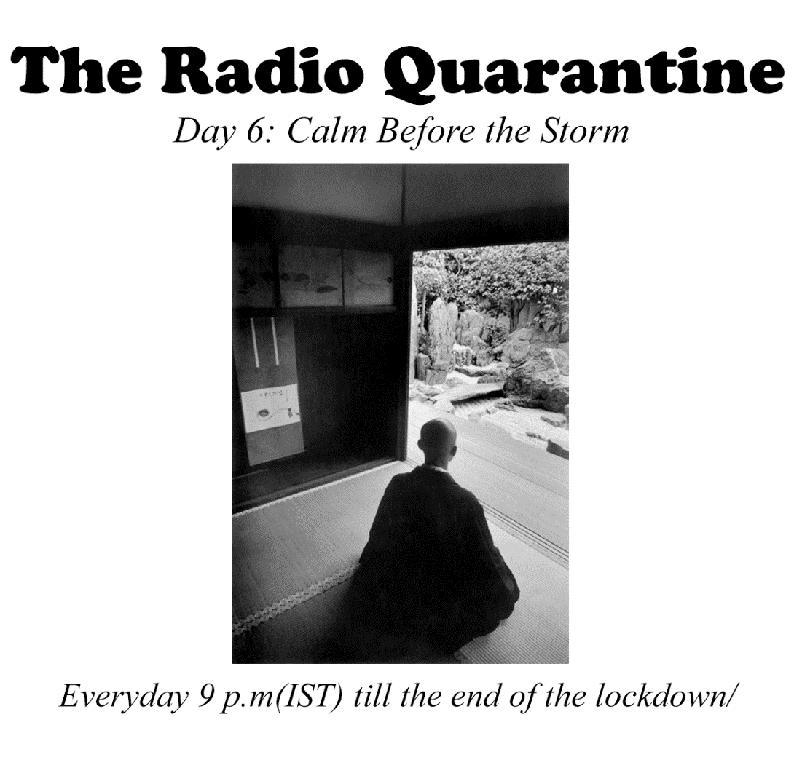

Day 06: Calm before the storm.

Tonight, we listen to Japanese composers of ambient and new age music. The pieces are peaceful, serene and sometimes dark. Some of these composers are long gone but the online algorithms have resurrected their sounds.

We have more interviews lined up for this week. Stay Safe.

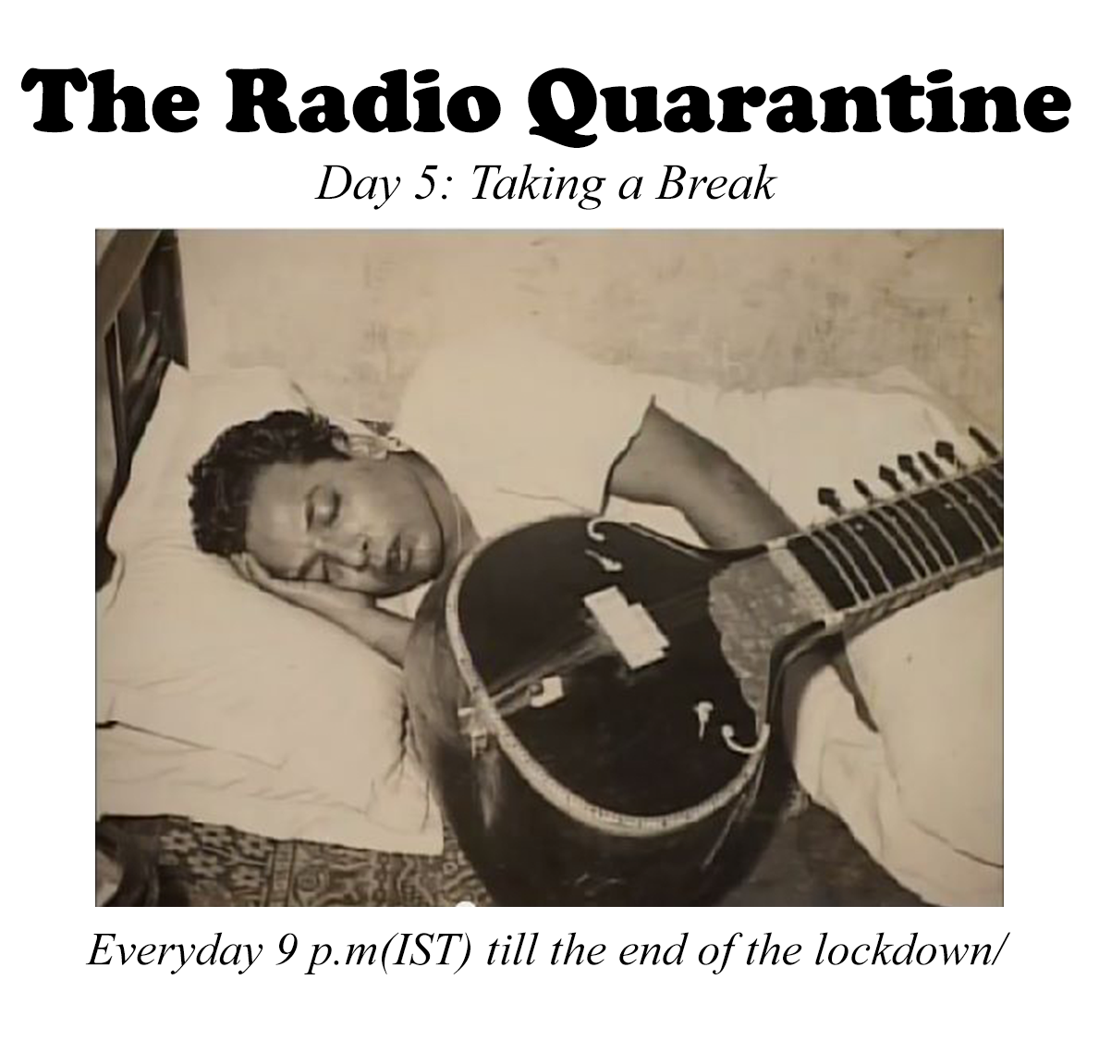

Day 05: Taking a break.

Keeping tonight mellow with some Dhrupad.

Tonight we listen to Raga Chandrakauns by Zia Mohiuddin Dagar on the Rudra Veena  
and Zia Fariduddin Dagar on Vocals

It is a raga for the night. It is a raga about longing and loneliness.

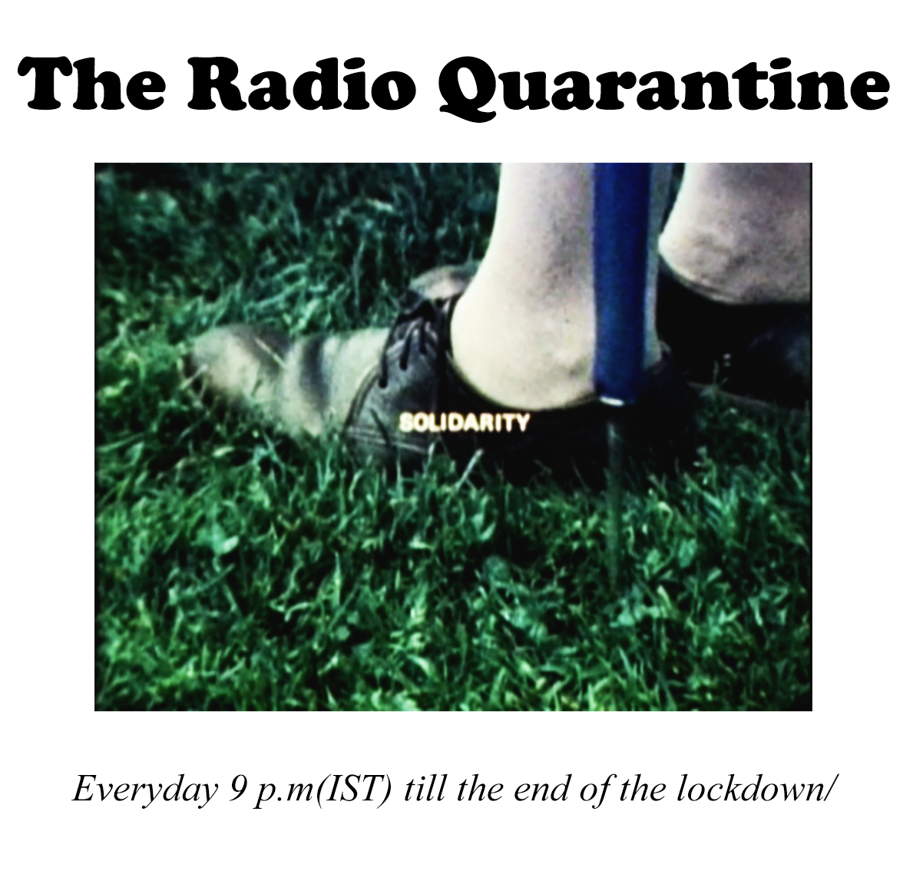

Day 04: Solidarity

This image is from Joyce Wieland’s beautiful film SOLIDARITY (1973). Tonight, we listen to music and sound pieces that reflect on solidarity.

There are other images being posted today of workers walking back home.

Tonight, we’ll have some special guests discuss the situation of the migrant workers trying to find their way back home.

**Special Guests**

Kavita Krishnan / Secretary of the All India Progressive Women's Association / Editor of Liberation, the monthly publication of the [Communist Party of India (Marxist-Leninist)](https://en.wikipedia.org/wiki/Communist_Party_of_India_(Marxist%E2%80%93Leninist)_Liberation) (CPI-ML) reads a poem by ____and discusses the situation of migrant workers walking home.

Arshia Sattar / Translator / Film Director/ Author/ Her abridged translations of the epic [Sanskrit](https://en.wikipedia.org/wiki/Sanskrit) texts, [Kathasaritsagara](https://en.wikipedia.org/wiki/Kathasaritsagara) and [Valmiki](https://en.wikipedia.org/wiki/Valmiki)'s [Ramayana](https://en.wikipedia.org/wiki/Ramayana) have both been published by [Penguin Books](https://en.wikipedia.org/wiki/Penguin_Books). Her book reviews and articles appear regularly in The Times of India, The Illustrated Weekly of India and the Indian Review of Books. Arshia talks about

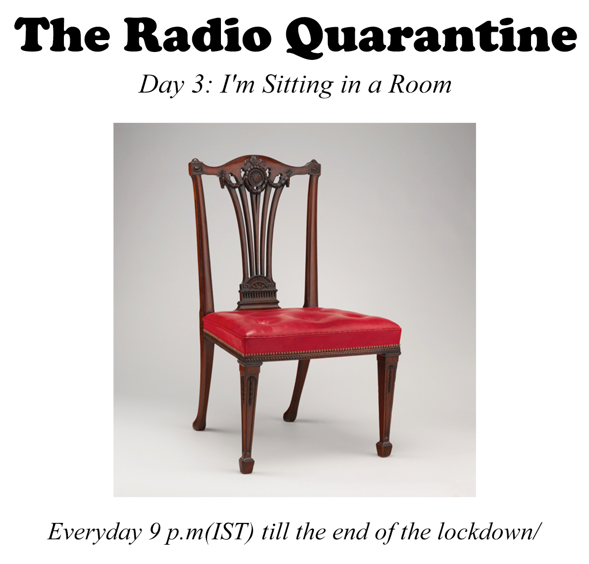

Day 03: I’m sitting in a Room

I am sitting in a room different from the one you are in now

Today, we relax and listen to Alvin Lucier’s classic ‘I’m sitting in a Room’.

I am sitting in a Room ranks as one of the finest achievements of modern music.  This is a piece that is remarkably personal, Lucier was trying to address his stuttering problem. Maybe its quietness has something to tell us about our present situation.

Tonight, we listen to this piece and other similar pieces.

Call, if you have poems or texts that you would like to read over the phone.

**Special Guests**

Savita Vijaykumar, ecologist & envitonemental activist, talks about being alone on an island

Arshia Sattar talks about ----

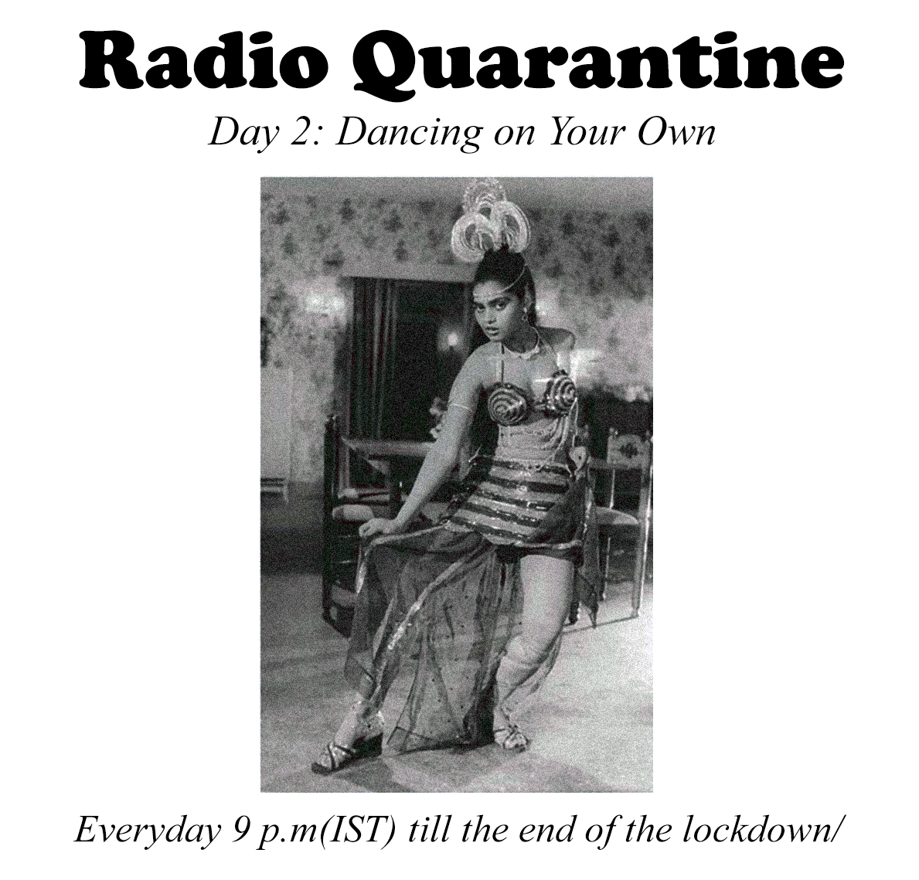

Day 02: Dancing on your own

After you accept your isolation, it’s time to dance on your own. It’s Friday.

We might be dancing on our own for a long time now and we need to practice.

Today, we look at sounds that make us dance from Bengaluru, Chennai, Berlin, and Detroit and beyond.

If you have songs, sounds or music in mind with isolation as the theme, please make your suggestions, requests to [isro.channel@gmail.com](mailto:isro.channel@gmail.com)

If you are an artist and you want us to play your music, send it to us as .mp3 or .wav files to the email address.

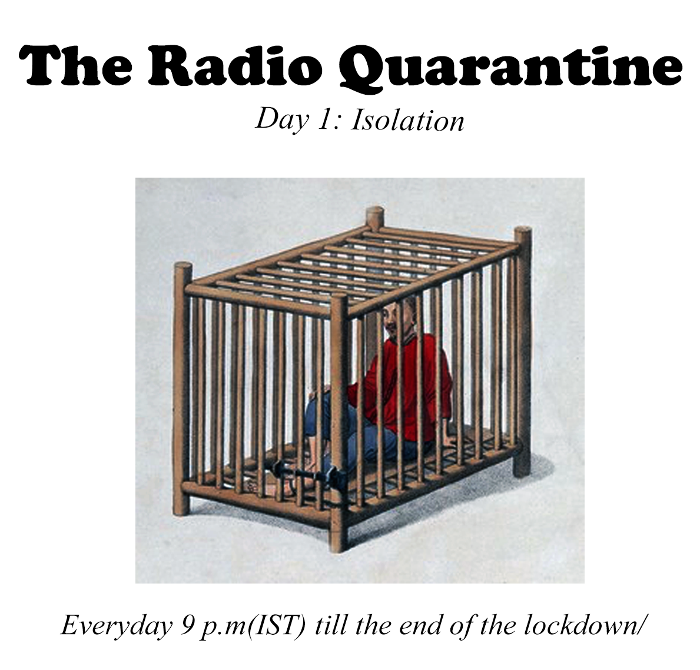

Day 01: Isolation

We streamline our Radio quarantine today with a theme: “ISOLATION”. We will explore music written with ‘isolation; in mind. From Joy Division to Beethoven, musicians have often written about isolation, loneliness or even independence - we’ll listen to some of this. Your suggestions are welcome.

If you have songs, sounds or music in mind with isolation as the theme, please make your suggestions, requests to [isro.channel@gmail.com](mailto:isro.channel@gmail.com)

If you are an artist and you want us to play your music, send it to us as .mp3 or .wav files to the email address.

**Special Guests**

Arshia Sattar / Translator /Author. Her abridged translations of the epic [Sanskrit](https://en.wikipedia.org/wiki/Sanskrit) texts, [Kathasaritsagara](https://en.wikipedia.org/wiki/Kathasaritsagara) and [Valmiki](https://en.wikipedia.org/wiki/Valmiki)'s [Ramayana](https://en.wikipedia.org/wiki/Ramayana) have both been published by [Penguin Books](https://en.wikipedia.org/wiki/Penguin_Books). Her book reviews and articles appear regularly in The Times of India, The Illustrated Weekly of India and the Indian Review of Books.

Arshia talks about Sita’s isolation

Abhijeet Tambe / Musician talks about his experience of traveling through the country and

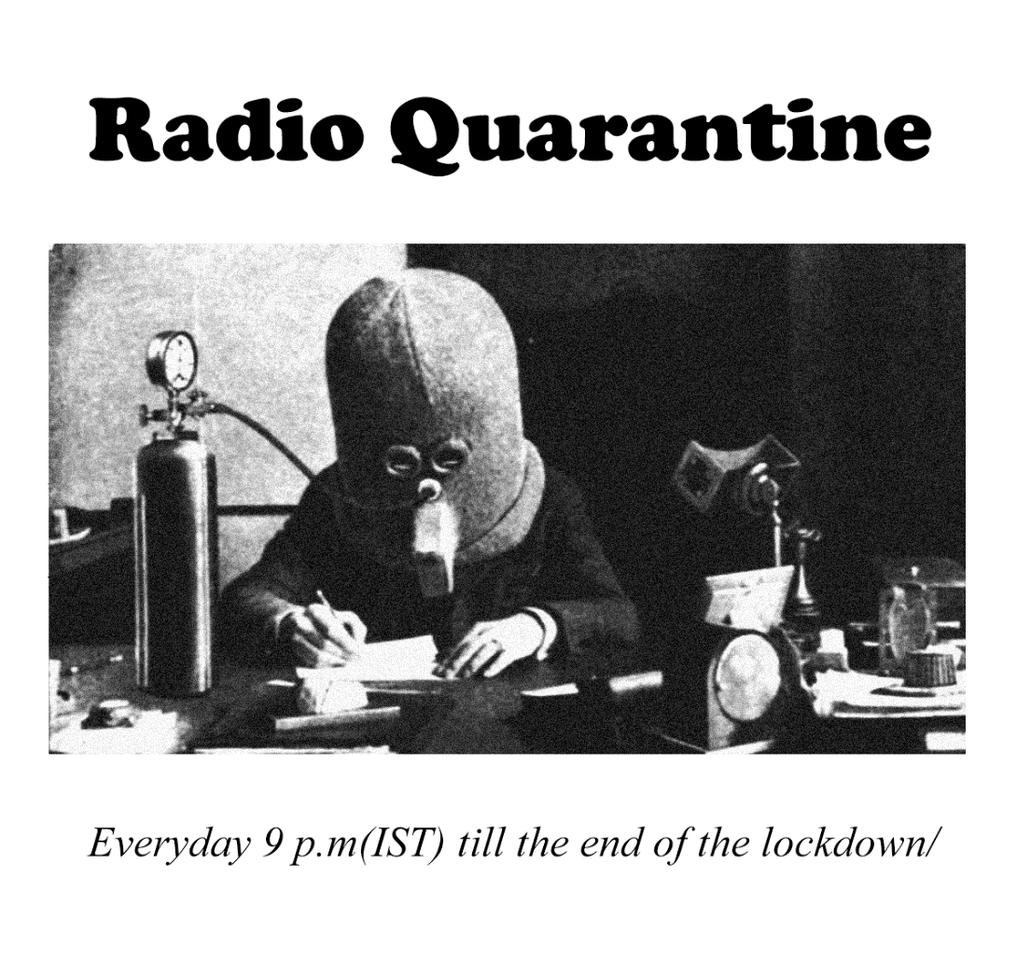

Had enough of the neighbours making that racket in the balcony with the frying pan?

This is the only radio station that you need during this lockdown. Broadcast starts tonight at 9:00 p.m.

Broadcast your requests, unwanted opinions, dire predictions, unsolicited advice, useless ideas...etc. on air by calling +919620964238 during the show. You can also send an email to [isro.channel@gmail.com](mailto:isro.channel@gmail.com)

**Lockdown Day 0: Ugadi Special** 9 p.m. (IST), March 25th, 2020